E-Commerce Delivery Performance Dashboard Documentation
Prepared by: Garima Kochale
Project Type: Data Analytics Project
Tool Used: Microsoft Excel

Objective
The objective of this project is to analyze and visualize delivery performance of e-commerce platforms using Excel.
- Analyze revenue across platforms
- Evaluate delivery time performance
- Understand customer ratings
- Identify delivery delays

Dataset Description
The dataset contains order-level information from platforms like Blinkit, JioMart, and Swiggy Instamart.
Columns used:
- Order ID
- Platform
- Product Category
- Order Value (INR)
- Delivery Time (Minutes)
- Service Rating
- Delivery Delay (Yes/No)

Data Cleaning & Transformation
The dataset was pre-processed to ensure accuracy and usability for analysis.
Steps performed:
- Checked for missing or null values and ensured data completeness
- Verified correct data types (numerical columns for calculations)
- Ensured Delivery Time and Rating columns were in numeric format
- Removed unnecessary columns that were not required for analysis
- Standardized categorical values such as Platform and Product Category
These steps ensured the dataset was clean and ready for analysis.

KPI Calculation
The following key performance indicators were calculated using Pivot Tables and Excel formulas:
- Total Orders: Count of Order ID
- Total Revenue: Sum of Order Value (INR)
- Average Delivery Time: Average of Delivery Time (Minutes)
- Average Rating: Average of Service Rating
- Delay Percentage:
Calculated as (Delayed Orders / Total Orders) × 100
These KPIs provide a quick summary of overall delivery performance.

Tools & Technologies
The project was developed using Excel features for data analysis and visualization.
- Microsoft Excel
- Pivot Tables
- Pivot Charts
- Slicers

Dashboard
An interactive dashboard was created using Pivot Tables, Pivot Charts, KPI cards and Slicers.
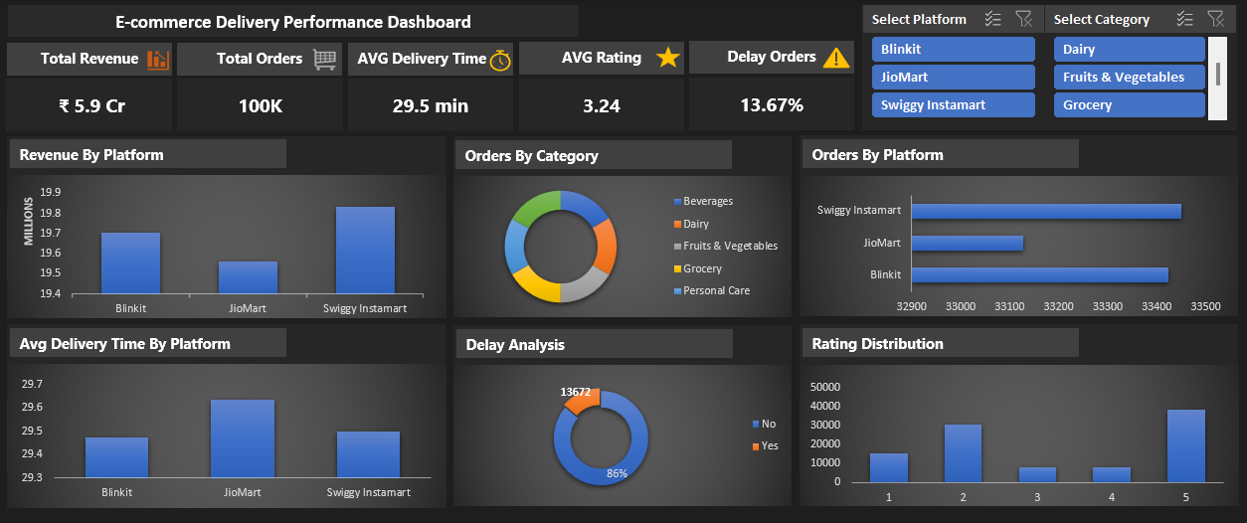Figure 1: E-commerce Delivery Performance Dashboard

Dashboard Components
The dashboard includes the following visualizations:
- Revenue by Platform
- Category Distribution
- Orders by Platform
- Average Delivery Time by Platform
- Delay Analysis
- Rating Distribution
Slicers are used for Platform and Product Category to enable interactive filtering.

Conclusion
This project presents a comprehensive analysis of e-commerce delivery performance using an interactive Excel dashboard. It highlights key metrics such as revenue, delivery time, customer ratings, and delay percentage to provide a clear understanding of platform performance.
- Helps identify high-performing platforms based on revenue and order volume
- Highlights variations in delivery time across platforms
- Shows overall customer satisfaction through ratings
- Identifies delivery delays and areas for operational improvement
The dashboard enables better data-driven decision-making and provides actionable insights to improve delivery efficiency.

